How to file the NM4W Annual Report with the NM SOS

- Go to https://portal.sos.state.nm.us/bfs/online To see a video on how to do this click on the green box – or just logon.
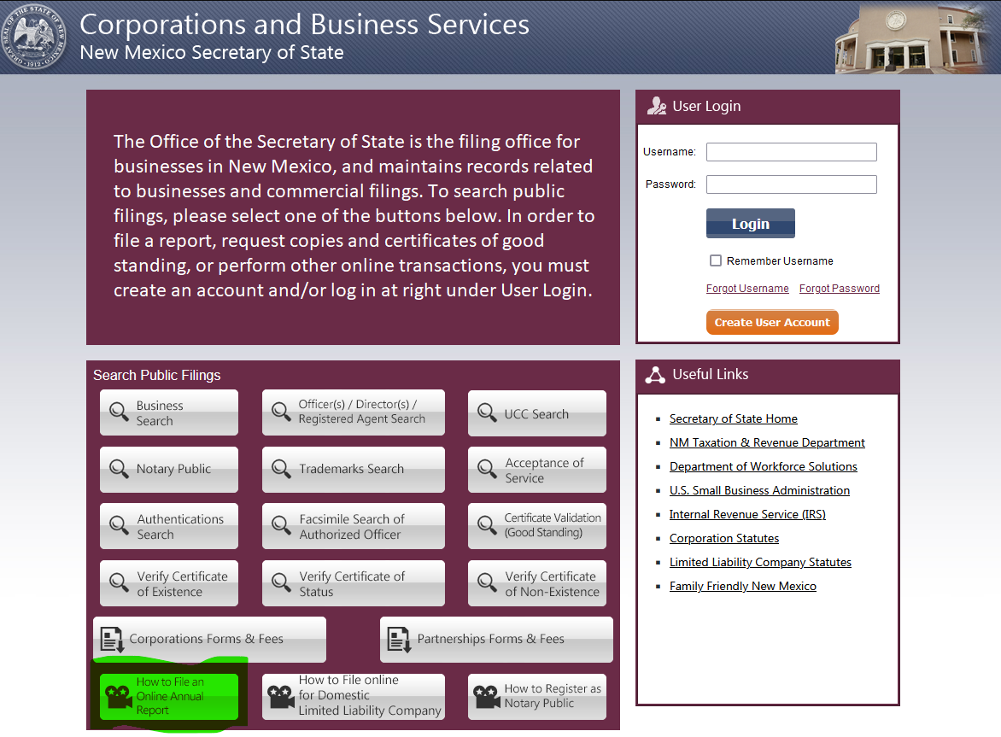
- Replenish the account if needed. This transaction will cost $10.
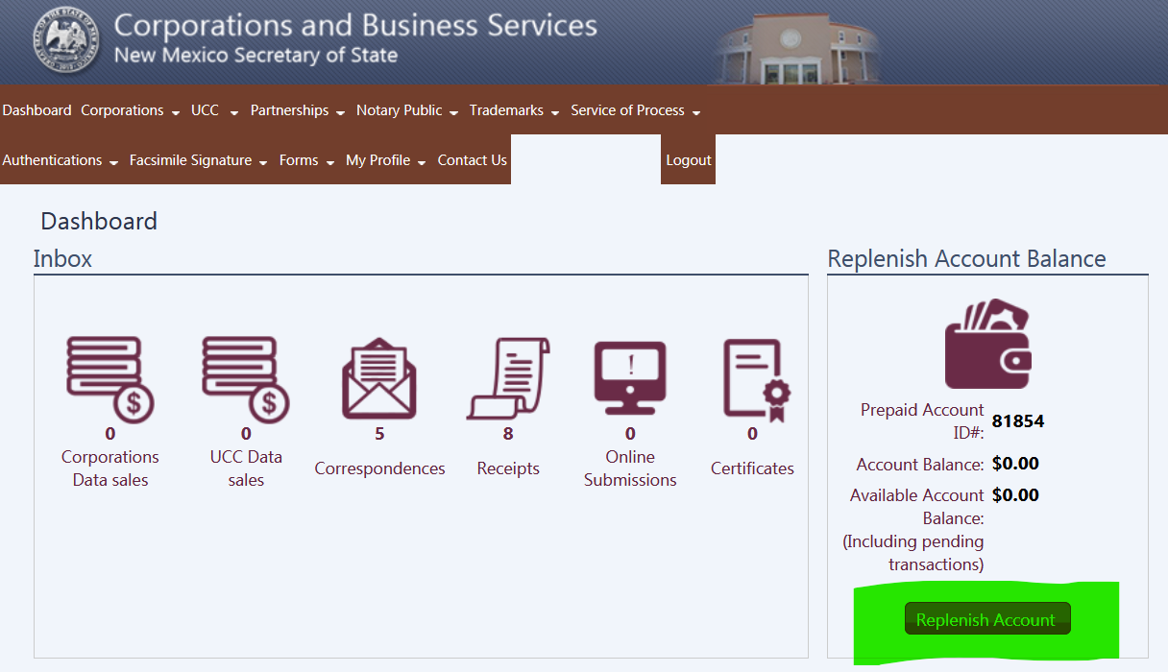
- Then you’ll be here. Click Done:
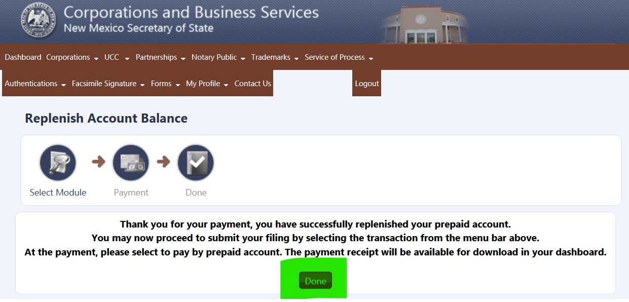
- Now you will be back here. Click on Corporations / Annual Report - Nonprofit.
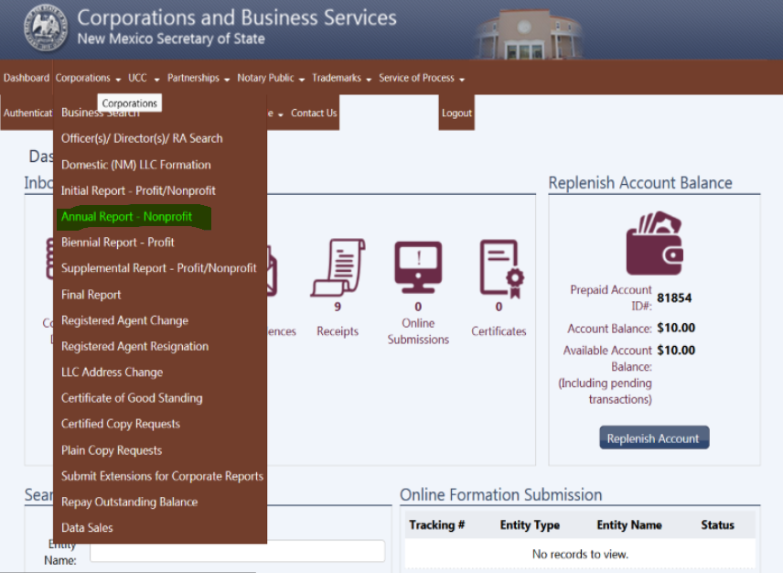
- Enter Entity Name as shown and press Search Entities:
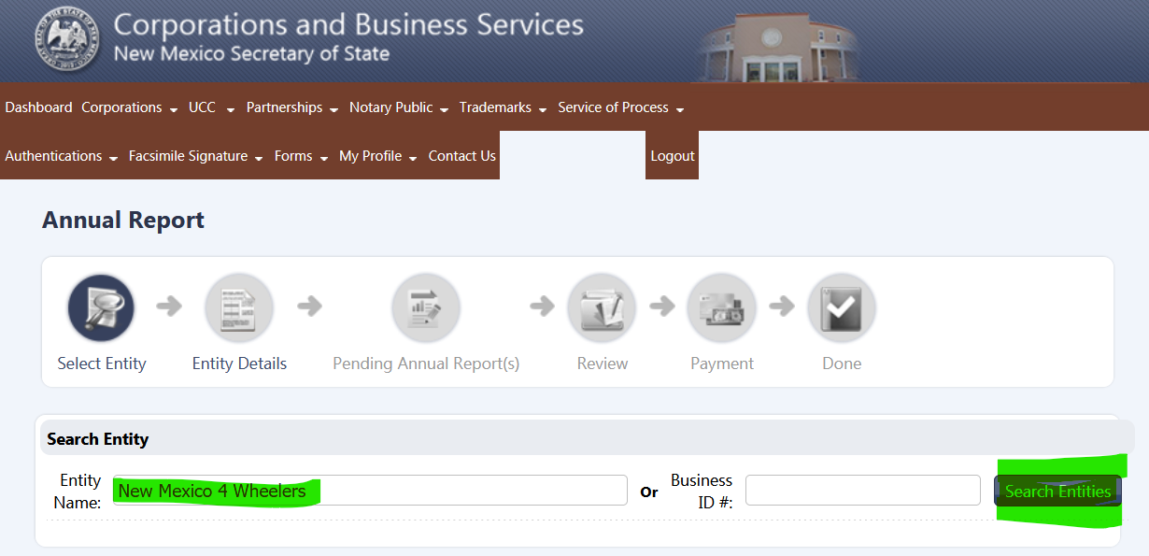
- You should see this screen. Press Continue:
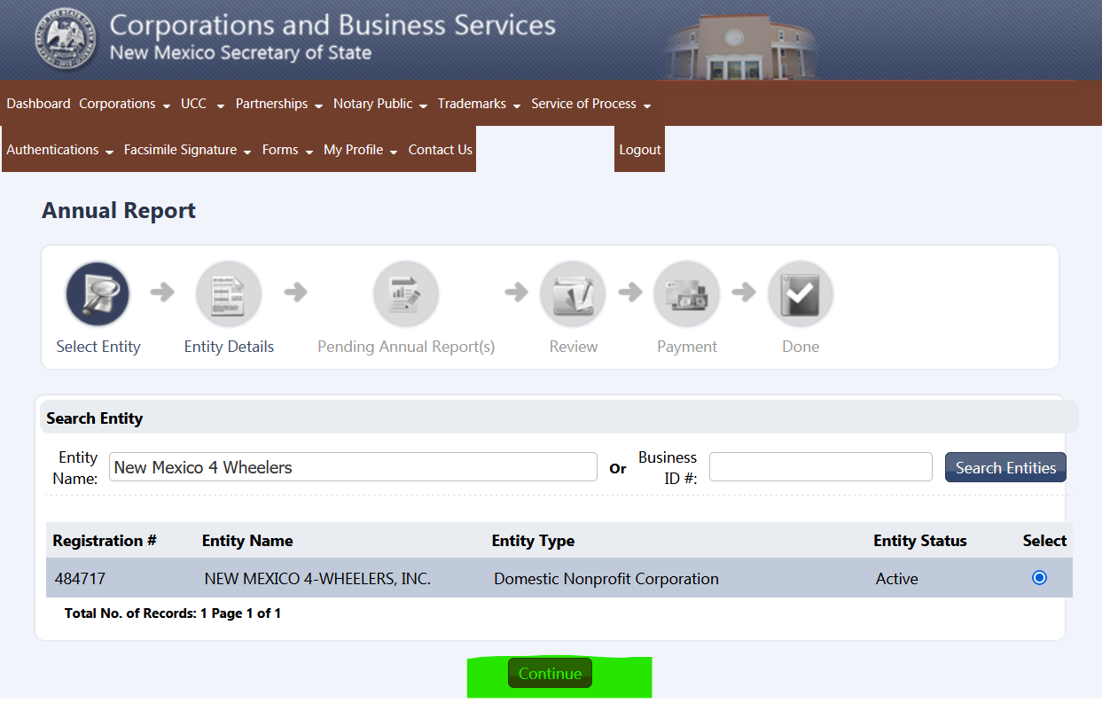
- You should now be here. Press Continue:
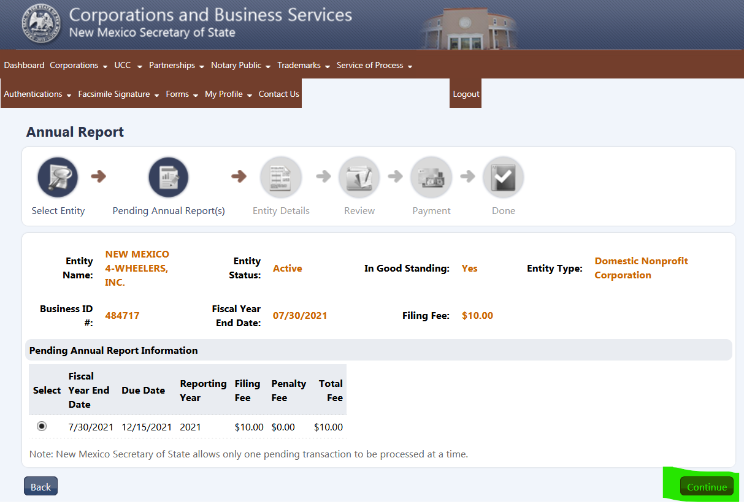
- At the bottom of the page, and using the Club website, update the list with ALL of the NM4W Elected Officers Information and press Continue. I find it easier to just Edit the valid Titles and Delete any others:
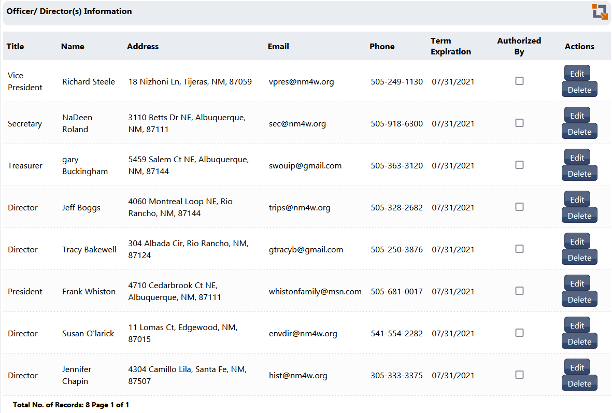
Don’t forget to update the Term Expiration Date:
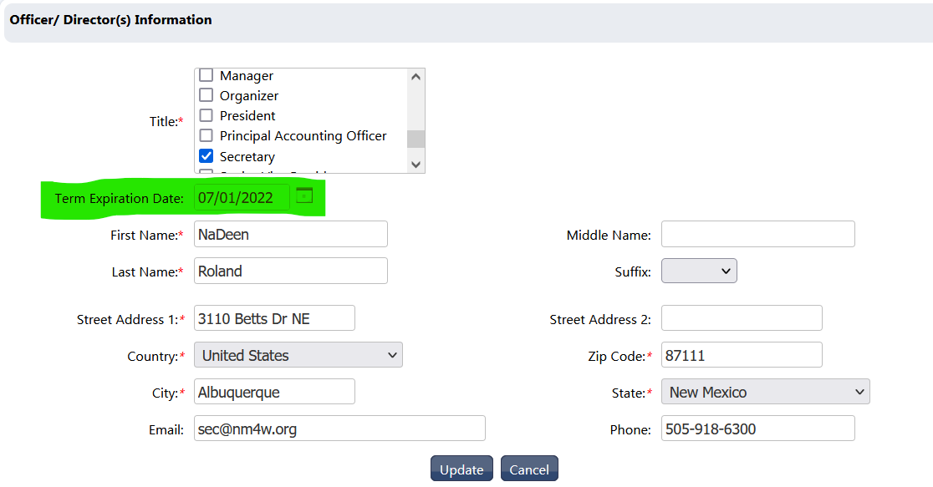
Here’s a completed list for 2021/2022. Also - check the 2 boxes indicated below (Pres and Vice Pres) then press Continue:
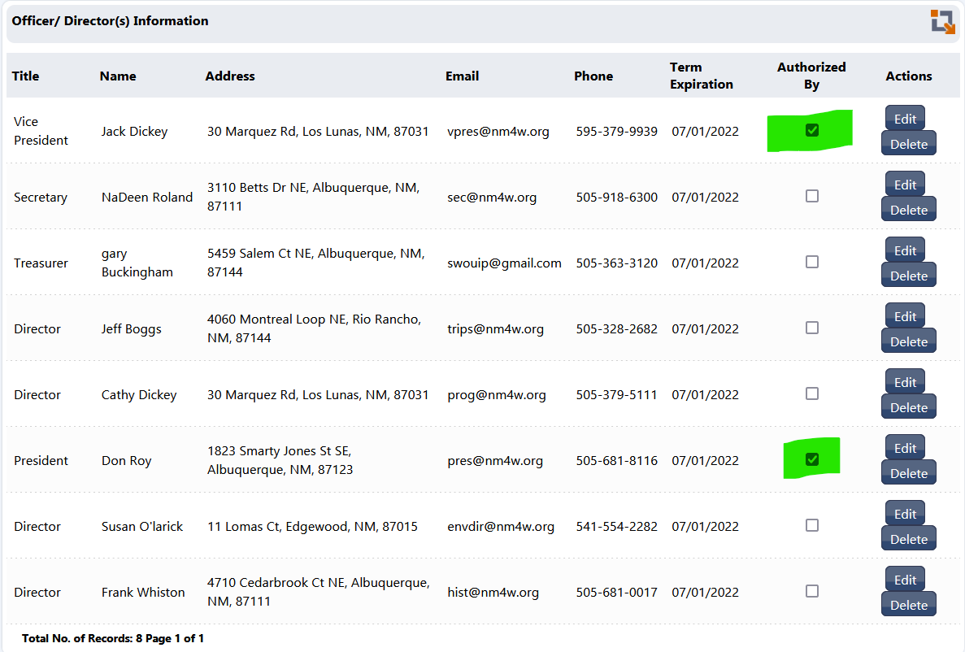
- At the bottom right on the next screen press Continue:
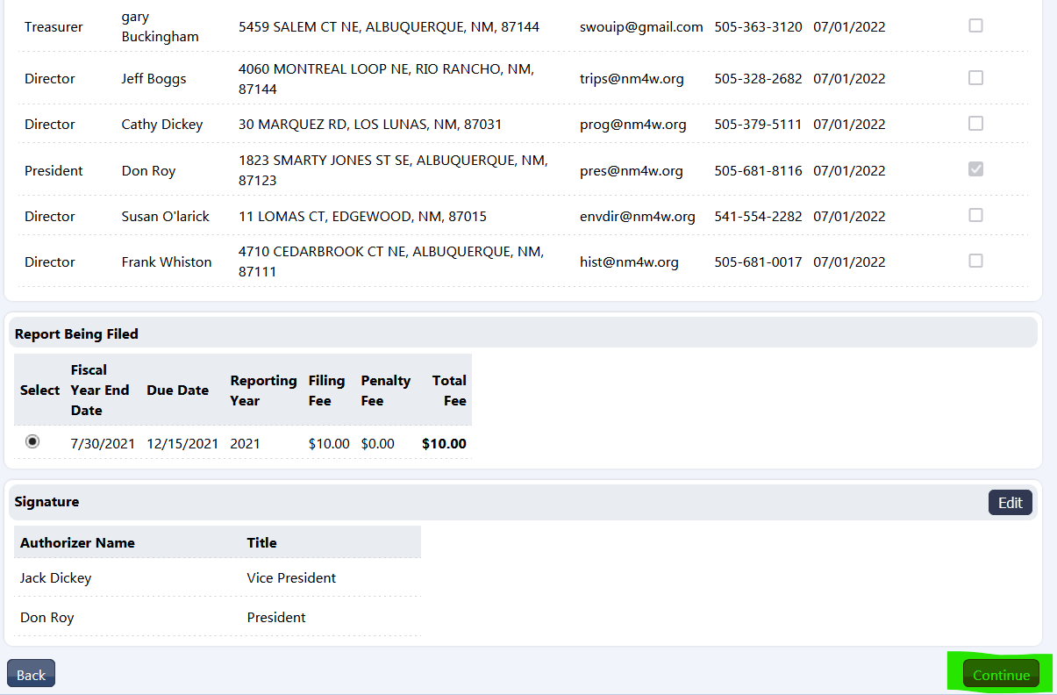
*******************************************************************************
Congratulations – you are done! It’s a good idea to print the Receipt and Filing Output. Save a copy and send a copy of each one to the NM4W Pres.
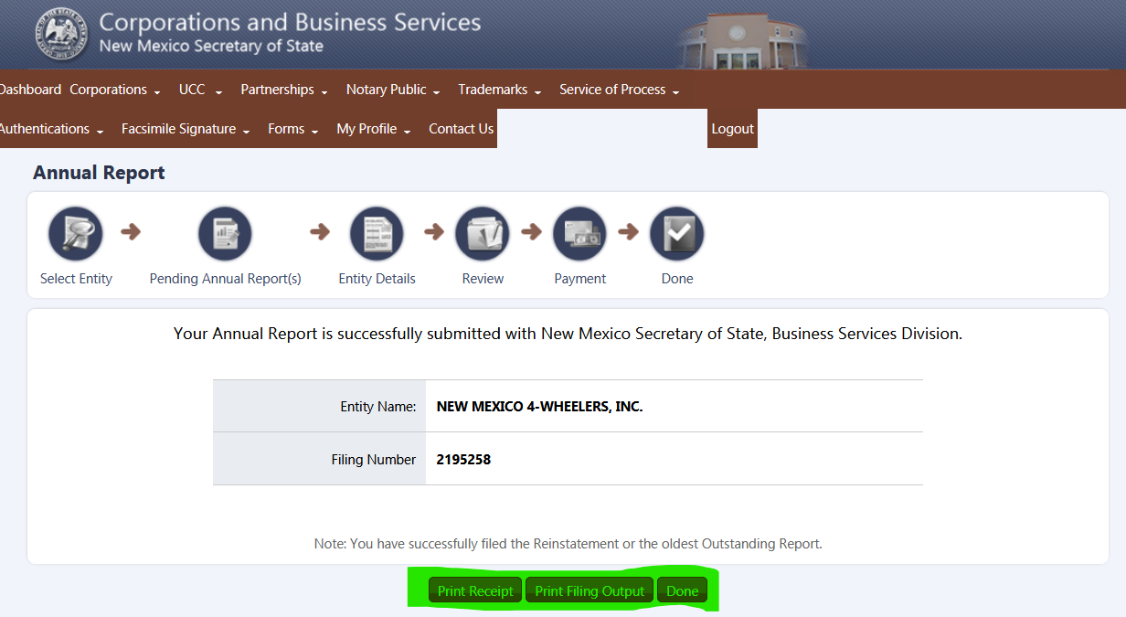
GaryB 12/4/2021

